**Project plan and first iteration report**

1. **Introduction**

This document intends to provide an overall description of the project named “Travel Guide” in detail. The project schedule and the plan of action is also discussed. The proposal document submitted would give an insight about what the project is about. The main outcome of the first increment was the high and low level design of the application. As of current state we have not deviated from our initial proposal that we submitted earlier.

1. **Project goal and objectives**

**Overall goal**

The project goal is to put together a set of related and useful web services under one umbrella. The app intends to serve the needs of a person who is in search for some trivial information about a place that he in planning or intends to travel to. The significance of the application lies in the fact that it serves as a one stop shop to interact with various information sources. Additionally the app lets users to interact with social media. The objectives of the application are as follows.

**Objectives**

* To reduce the user time in searching for information across various sources.
* To develop a system architecture that can integrate the different features that the system proposes.
* To ensure that each iteration is tested thoroughly before heading to the next one.
* To develop a user friendly application.
* To provide user a tool to keep track of items that are required for the travel and the duration of the stay.
* Ensure that the user never misses important information in a touring country by providing the translate feature that translates the text into the user specified language.
* The user would never miss out on famous tourist locations as our app has a feature to suggest famous tourist attractions or hangout spots in a place.
* A tourist never feels away from home. The accommodation finder is a tool that helps the user in selecting his home away from home.
* Currency conversion is one of the major problems that tourists face when visiting other countries. The users of this app have no such worries as we take of currency conversions based on the latest foreign exchange rates.
* The user can prepare for the weather of the place he is visiting. The system predicts the latest weather information of the place of interest.

1. **Project background and related work**

The app is not a new invention or a brand new concept. Instead it intends to provide a mash up of the various web services that are present in full or in partial implementation in the below references.

* Weather Pro: This app offers information on the weather intricacies of several places around the world using cloud technology [1]. The application that we are developing uses simple REST API technology rather than the cloud to get information about a specific place or region of interest. The UI would be significantly different from what the Weather Pro app has in place.
* TripAdvisor: This app offers reviews on hotels, restaurants and places of attraction at the mentioned travel destination [2]. In coherence with this our proposed app is only a suggestion service on the various places of accommodation. But the primary contrasting factor is that in the app being developed there is no ranking or reviews of the places suggested.
* Hostel world: This application gives the list of budget friendly hotels present in and around the place being visited [3]. This application only retrieves a list of hotels or accommodations that are light on the pocket. But in our app we provide a list of all the hotels and accommodations that are returned by the API service.
* XE Currency: This tool is ideal for getting the live currency information [4]. The tool mainly acts akin to a currency conversion chart. The “Travel guide” app on the other hand provides specific rates for the currencies selected by the user.

**Significance**

The major significance of the application lies in the fact that the all the useful services are provided under one system. This saves time wasted in surfing the web to get the required information from the various apps or websites. The user need not create a new profile or provide redundant data to the system. He can authenticate himself using his Google+ or Facebook account. The system ensures that the user is prepared and has planned his travel with all the required information in hand. The user also has the added advantage of connecting to his social network and sharing his thoughts about the travel and stay at the destination.

1. **Proposed system**

**Requirements specifications**

* The application will provide users facility to login with their Google plus account.
* User should have the flexibility to login with his Facebook account.
* The system will display the user his information along with his profile picture.
* The user shall be provided with six options or features that the user can interact with.
* Feature of currency conversion shall be provided.
* Latest weather predictions of the place of interest shall be displayed to the user.
* Given a place, the system must suggest and display the famous tourist attractions and other places of interests.
* There shall be a feature for the user to keep track of items and tasks that the user intends to buy or plans to do during his course of travel or stay.
* Accommodations options such as hotels and other places to stay shall be suggested to the user, based on user’s choice of place.
* Text translation into the language chosen by the user is to be provided

**Workflow analysis**

The first and the most fundamental workflow of the application is that of the designing the UI for the system. This involves selecting the proper HTML elements and arranging the elements in an appropriate manner. It includes making use of the CSS attributes to style the UI of the application. Each page of the application is to be custom designed for suiting the needs of the service or feature being provided over that page.

Second, the information on selecting API and implementing the API features into the system. This deals with the selection of API from a list of multiple options. This process is to be repeated for each of the service being offered.

The third workflow deals with the creating a local database to store and manipulate the tasks or items to be tracked for the user. This flow ends with the integration of the individual components of the system to end up with a stable application. The appropriate workflow analysis is provided by the sequence diagrams provided in the first increment report.

**Technological and architectural requirements**

On the technological facet of requirements the system needs to interact with the external REST APIs provided. We require the interaction with service of Google plus and Facebook for the login functionality to be implemented. Constant interaction with services provided through APIs should be present for the system to be available for usage. Most of the interaction would happen over the REST technology and JSON would be the primary medium of interaction. For the service of tracking tasks and items the system would use a local storage and have to interact with the native library features to display notifications on tracked items.

Java would be the primary language for implementation of the business logic. HTML, JavaScript, Angular JS, JQuery and CSS would form the core framework for the UI layer and UI interaction with the REST services offered through APIs. We would try to incorporate the Ionic framework and bootstrap JS for multiple platform implementation and better UI experience of the user.

The architectural requirements would focus on the providing an architecture that can integrate the various services offered from external sources. This provides a challenge in coming up with a flexible architecture that has the freedom to integrate various sources of service providers to provide a complete experience to the user.

**Framework specifications**

The system would be a flexible framework that can incorporate the services that are customized to suit the user and application needs. The system architecture would comprise of a client server architecture in which our application would be a client accessing service hosted or offered through different servers. Internet would be the medium of communication between the application and the services hosted in the web. One of the service that the application offers requires the traditional 3 tier architecture where in the data is stored through the UI layer into the business layer and ends up in the database. The system architecture is represented in the diagram below.

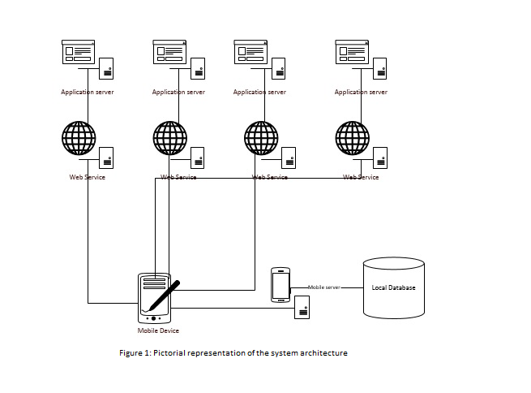

**System specification**

**Primary services and their features**

The following are the primary services that the system offers to the user. The APIs being provided here are initial intuition and may change during the project development phase to provide better service quality. The priority of the tasks are not decided as this moment and would be implemented in the ad hoc fashion. The timeline for each activity is a bit complex to predict and it would be premature to comment now.

* Currency conversion based on the current foreign exchange rates. This service is offered through the “Google finance API”. This service provided over the URL “<https://developers.google.com/finance/?hl=en>”. This would require the inputs of currency codes and the amount to be converted. The output would be a value in another currency. The service implementation is relatively on the easier side.
* The next service offered is the translation of the text provided to a language of user choice. This service is offered by the by “Google Translate API”. The URL for the REST service interaction is “<https://cloud.google.com/translate/docs>”. The translation service takes the input of the source and destination language codes along with the text to be translated. The service generates the translated text. The service implementation although easy would be time consuming.
* For providing the feature of suggesting the places of interest the system would interact with the “Google Maps API” and a third party service that interacts with this map API. “<https://developers.google.com/maps/?hl=en>” is the URL for interacting with this API. This service implementation would be a tough job as it deals with providing location and details of places that being suggested. The input for this file would be the coordinates of the place being queried by the user. The output would be a map view of the places being suggested.
* The feature of creating, tracking and deleting items and tasks to be done is being built by the system using the local database. This service would be designed within the system. This service implementation deviates from the normal process web service consumption. Instead we would develop a web service that stores, retrieves and manipulates data to and from a local database. This task would require considerate time and effort.
* The weather prediction is based on the data being returned from the web service provided by AccuWeather in the form an API. The URL for this REST service is “<http://apidev.accuweather.com/developers/>”. The task mostly concentrates on the UI display of the information being retrieved. The service consumes the data of place for which the weather is predicted. The output of the service would be a UI displaying the weather information generated by the service. The complexity in implementing the web service is relatively moderate and time consuming.
* For the feature of accommodation suggestions we are yet to finalize on the API to be made use of. This would be winded up pretty soon. This service implementation would require little time as there is a reuse of code and ideology taken from the implementation of the places of interest service. The time factor is moderate.

1. **Project plan**

The proposed project plan is outlined the by the screen shot from the Kanban tool. The project is divided into four phases each of which is guide lined by a test driven approach. Each iteration has four tasks categorized by stories for each iteration, designing phase, building the service through implementation and testing. The final task is to store the completed tasks for future integration.

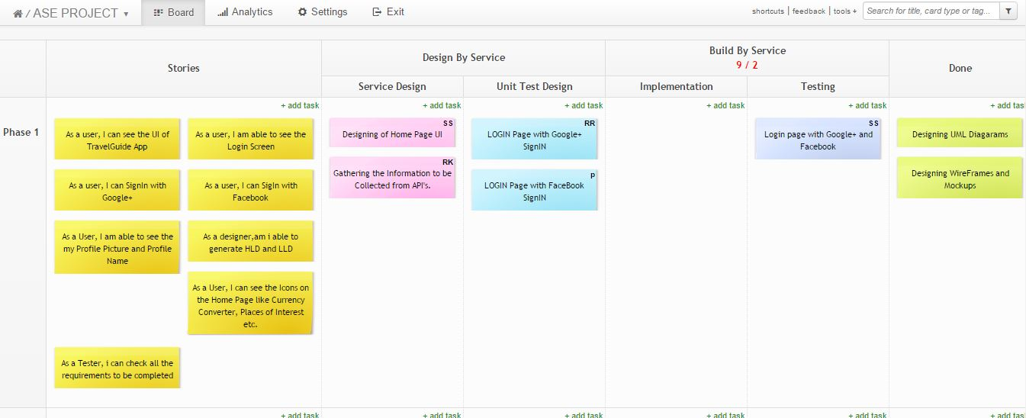

Figure 2: Depicting the schedule and plan for phase 1 of the project.

Phase 1:

This phase mainly deals with the designing the system for the implementation phase. The tasks of this phase mainly focuses on the UML diagram and collecting the necessary information for the realization and the implementation of the system. The end result of the phase 1 are initial screens of the application. These are just the rudimentary level implementation screens and these may change during application development process. Unit testing of the login service with Google plus and Facebook is performed. Concluding the phase 1 is the testing of the integration services of Google plus and Facebook login and their redirection to home page.

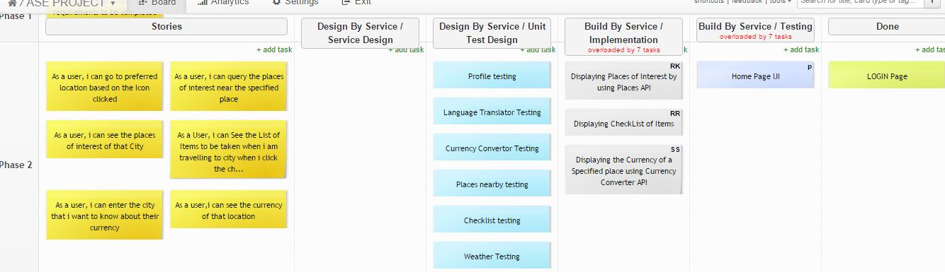

Figure 3: Depicting the schedule and the plan for phase 2 of the project.

Phase 2: The main goal of this phase is to generate the UI and incorporate the individual web services through the implementation methods specified in the earlier sections. The tasks are more leaning towards the usage of the REST API services and implementing them in the mobile application. The tasks of this phase are more towards the implementation of the code to develop the web services. Each service is implemented and tested individually.

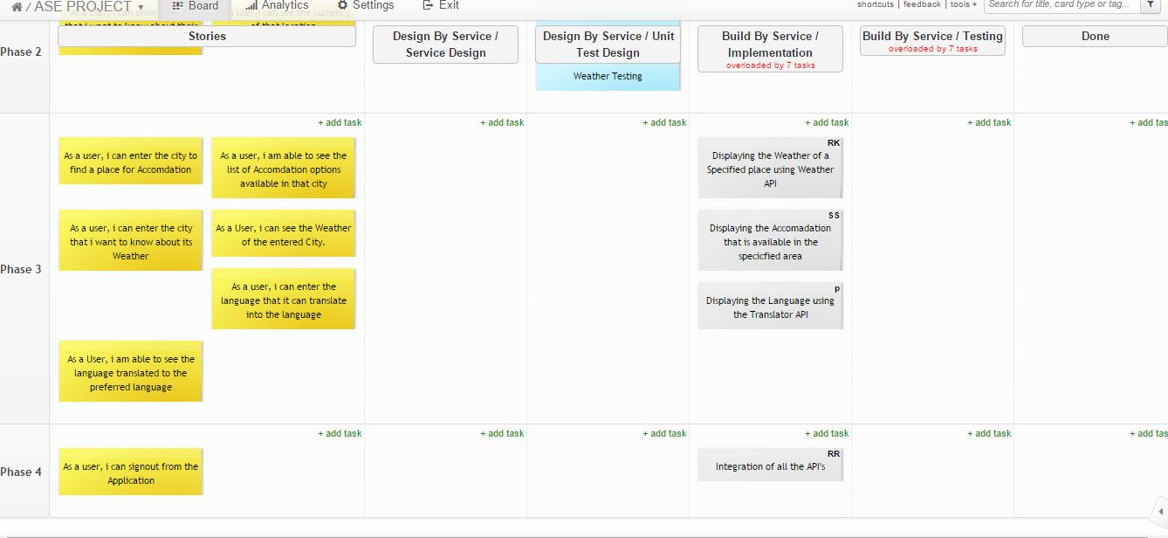

Figure 4: Depicting the schedule and plan for the phase 3 and 4 of the project.

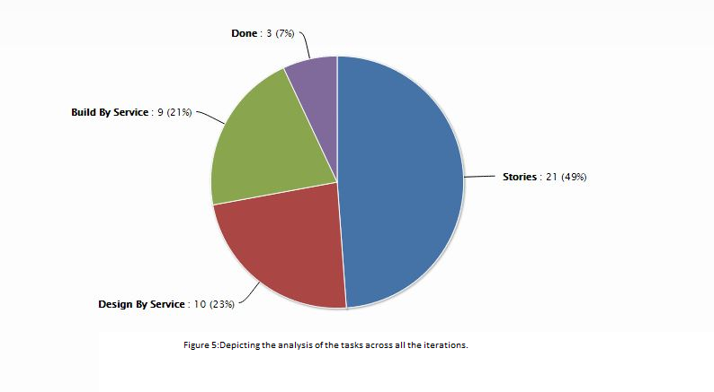

Phase 3 and 4: These phases are primarily intended for the integration of the various web services and the final output of the application. This phase would deal with the integration testing of the system. It yields the final proposed application. But the final step in the process would be to perform UAT before the application is deployed to the production environment. This phase is the final phase in the development of the application.

**Timelines of the project**

The timelines of the project schedule are in coherence with the timelines of submission for each of the phase. As of the current state there are no deviations from the project schedule.

1. **Bibliography**

[1], [2], [3] and [4] – Content referred from the article “The world’s 50 best travel apps” by the Time out group. URL: <http://www.timeout.com/travel/features/1169/the-worlds-50-best-travel-apps>

**References:**

“Packing list” by Travellerspoint Foundation. URL: <http://www.travellerspoint.com/packing-list.cfm>

“Kanban tool” used for the planning phase, URL: <http://kanbantool.com/>

The guide for Google plus login URL: <https://developers.google.com/+/web/signin/>

Facebook sign in option guided by URL: <https://developers.facebook.com/docs/facebook-login>